* Rod Dahlgren * Collectible Car Consulting *
Member of I-VAN International Vehicle Appraisers Network www.i-van.org

*Personal Experience with Special Interest Vehicles for over 30 years.
*Available as consultant for:
*Restorations
*Appraisals
*Shipping (domestic & foreign)
*Purchasing Representative
*Inventory of projects (basket cases)
*Mechanical Evaluations including Accident Investigations
*Expert witness

Completed restorations of:
Chevrolets covering model years 1955 through 1972.
Ford Thunderbirds 1957,58,59,60,61,64.
Ford Pickups 1956 stock and custom.
Cadillacs 1936 to 1976 including ’53 & ‘59 Eldorado and ’58/59 Broughams
Mercedes Benz 190SL
Performed mechanical restoration and export service for over 400 special interest vehicles.
Purchase agent for customers in several countries.
Performed mechanical investigations for law enforcement agencies.
Testified as expert witness for value of vehicles.

Experienced in these Makes:
General Motors Vehicles
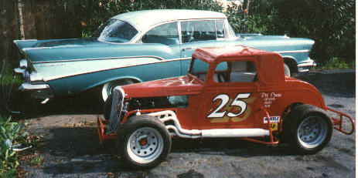
Ford Motor Co
Chrysler Products
Studebaker/Packard
Rolls Royce
Austin Healy
MG
Pantera
DeLorean
Ferrari
Trabant
Mercedes Benz

Race Cars:
Track Roadsters/Hardtops/Jalopies
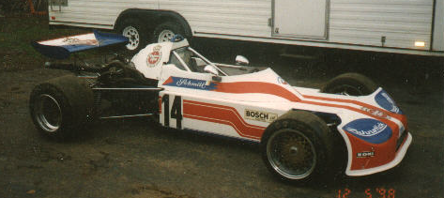
Sprint Cars/Midgets
Stock Cars
Dwarf Cars/Legends
Quarter Midgets/ Go-Karts
Formula Cars

Motorcycles:
AJS/Triumph/BSA/Ariel/Vincent
Bridgestone/Kawasaki/Yamaha/Honda/Suzuki
Harley Davidson/Indian

Fabrication of racecars and related components.
Chassis Theory, handling, suspension, weight & balance.
Driver of race cars since age 5.
Motorcycle rider and formerly raced motorcycles (A.M.A.).

Hold Private Pilot License.

Represented clients several states in U.S. New Zealand, Australia, Middle East, Scandinavia and Europe.
By appointment only please (707) 226-5859 Fax (707) 226-5060 E-mail funcars4us@hotmail.com

